**Basic Structure of a Web Page (Module 1 and 2)**

1. Create a webpage named “florist.html” (webpage for a florist), using HTML5 structural elements like header, nav, article, section, aside, footer etc.

* Webpage should contain florist name at header (name of your choice).
* Place 3 navigation links at nav bar named:
  + Home
  + Flowers Gallery
  + Contact Us
* Display a flower bouquet gallery in aside bar.
* Write some text about flower shop, shop’s owner and shop’s clients using section and article tags.
* Display copyright information of webpage and contact information at footer.

**Required Output:**

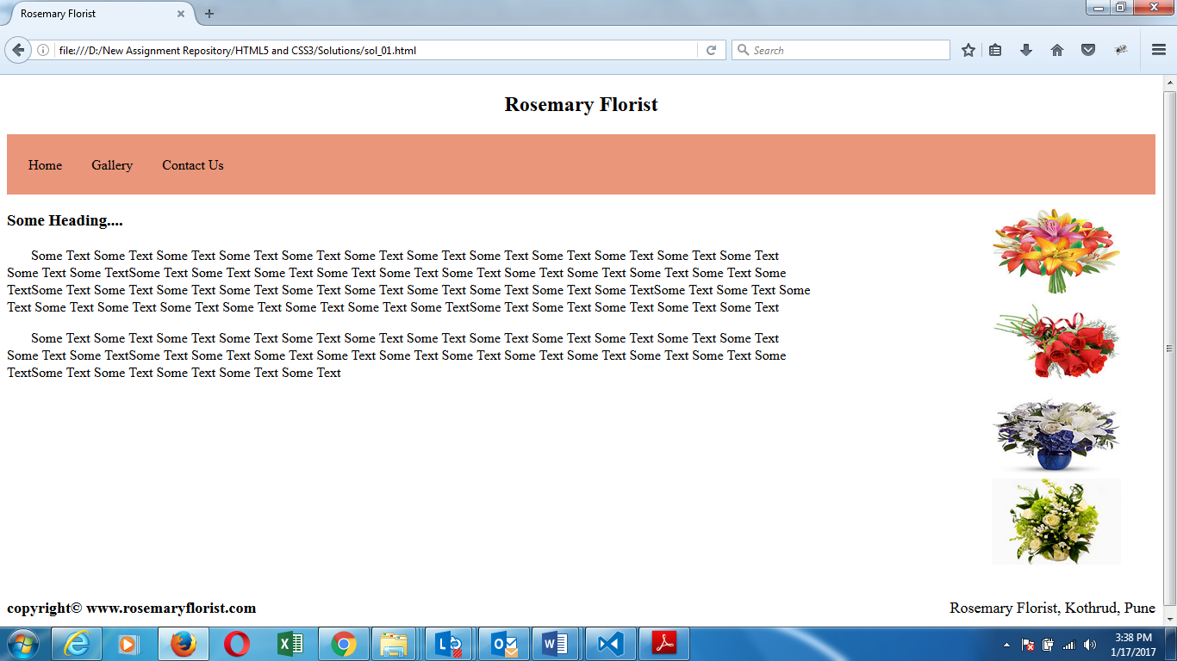

1. Create a home page layout as shown below using HTML5 structural elements.

**Required Output:**

